Functionality of Voice recording application as in original Voice Memos application with a few exceptions.

First screen – recording new Voice Memos.

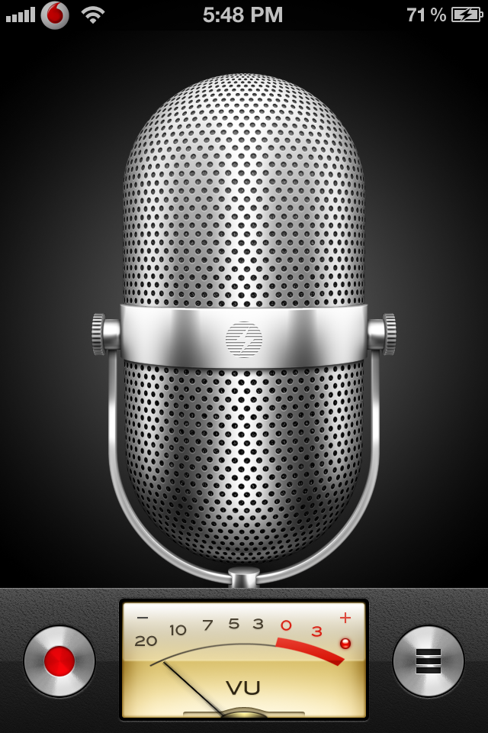

Left button to start and stop recording voce memo. Right button to go to voice memos list.

When user press record button, recording of voicememo will start. Left button changes to pause recording button. When user press voicememos list button, recorded voice memo automaticly save to voicememos list. Screen nr. 2:

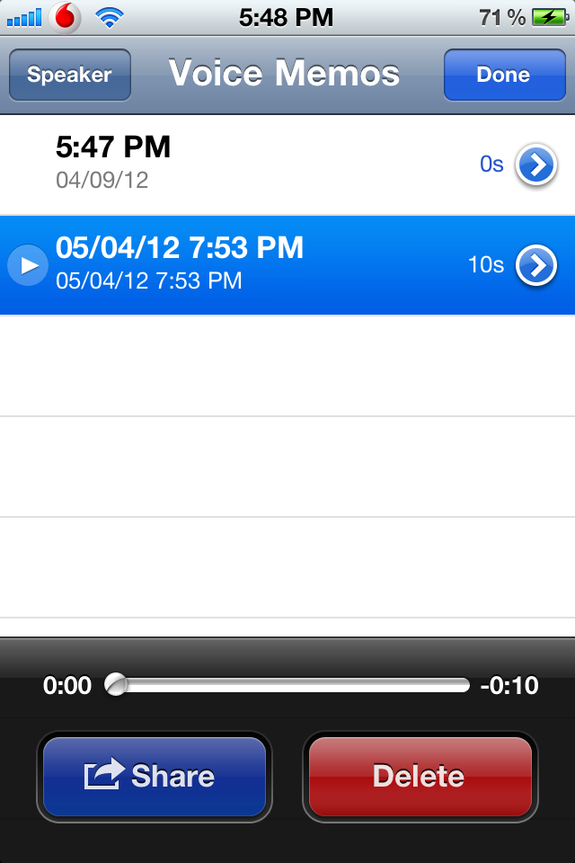

There are list of all saved voice memos, sorted by date and time. Last saved voicememo in the top of list. From this screen It is possible to play voicememos. When voice memo playd till the end next voicememo vill start paying.

Each voice memo will have thouse attributes:

1. VoiceMemo ID
2. Recording Date and time
3. VoiceMemo length (minutes and seconds)
4. Memo label (there are possibility to set memo for each recorded VoiceMemo)

Example of voicememos list:

|  |  |  |  |
| --- | --- | --- | --- |
| ID | Date Time | MemoLabel | Length |
| 1 | 2012.09.01, 18:35 | Idea | 1:22 |
| 2 | 2012.09.01, 17:30 | Idea | 1:28 |
| 3 | 2012.09.01, 16:35 | Meeting | 2:22 |
| 4 | 2012.09.01, 15:15 | Idea | 6:22 |
| 5 | 2012.09.01, 14:22 | Meeting | 11:15 |

If user delete by example voicememo nr3, all memos will be renumerated as in example below:

|  |  |  |  |
| --- | --- | --- | --- |
| ID | Date Time | MemoLabel | Length |
| 1 | 2012.09.01, 18:35 | Idea | 1:22 |
| 2 | 2012.09.01, 17:30 | Idea | 1:28 |
| 3 | 2012.09.01, 15:15 | Idea | 6:22 |
| 4 | 2012.09.01, 14:22 | Meeting | 11:15 |

Is will be possible to add and delete labelt to the list.

It will be possible to group voicememos by labels and play voicememos fore ach group.

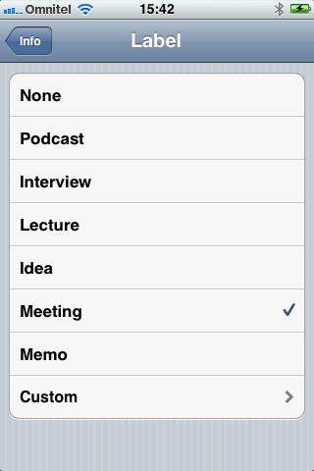



There will work backup to iCluod as in original iOS application